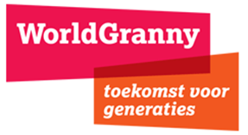
\ 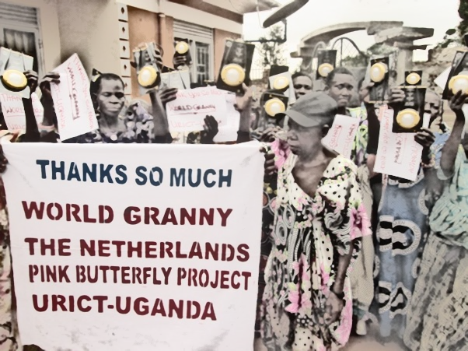
WorldGranny Annual Report 2020

Contents
WorldGranny Foundation Annual Report 2020 2
1. URICT – Support to grandmothers during the COVID-19 crisis 2
2.1. The Pink Butterfly Project (PBP) continued with emphasis on food security 3

WorldGranny Foundation Annual Report 2020

Since 2004, WorldGranny is the Dutch non-profit organization dedicated to the quality of life of older people worldwide. With a total turnover of almost 7 million euros, we have been able to support ten thousands of older people and their (grand)children in small scale projects in Africa, Asia and Latin-America between 2004 and 2016. In 2017 we wrote a substantive report on the activities WorldGranny had undertaken in the last 12 years. We noticed the meaningful progress towards achieving the main Millennium Development Goals (MDGs) and addressed the 2030 Agenda for Sustainable Development which sets the vision for the next 15 years of global action. These Sustainable Development Goals (SDGs) include the unfinished business of the MDGs but address a wider, truly global agenda.
In many regions, especially in Africa, HIV/Aids has still an enormous impact on the population. The Dutch Grannies2Grannies group continues to support local NGOs, especially in Uganda, where new houses are being built for grandmothers who support their orphaned grandchildren. Taking all this into account, WorldGranny decided to continue working on the SDG and aging agenda as WorldGranny Social Enterprise. The activities of the WorldGranny Foundation, which faced challenges with respect to fundraising, will be geared towards emergency assistance and incidental project support. A strategic decision was made to no longer actively fundraise, but support projects with the existing funds and recently made donations.
Since 2017 WorldGranny is partnering up with the Ugandan NGO URICT that create an enabling environment for 50 grannies in Kamuli Eastern Uganda and implement the so-called Pink Butterfly Project and this project has been the main focus in 2020 as well.

URICT – Support to grandmothers during the COVID-19 crisis

WordlGranny has supported URICT in their efforts to create an enabling environment for the grandmothers that looked after their orphaned HIV/AIDS affected grandchildren. The outbreak of Corona Virus – Covid 19 threatened the entire project when the government quickly moved in to enforce punishing and unforgiving restrictions. Gathering was banned, public transport stopped and so many restrictions which meant that we had to develop new strategies to get the project back on track.
Later in the months which followed the project coordinator contracted Covid 19 and this was a blow to URICT and delayed the final preparation of this Annual Report on the project. The URICT Team is happy that despite odds, the NGO was able to support the grandmothers grannies looking after their Orphaned HIV/AIDS affected grandchildren.
URICT is creating an enabling environment for older women in Kamuli.

2.1. The Pink Butterfly Project (PBP) continued with emphasis on food security

Since 2017 URICT has been implementing the PBP with a €5,000 Euros annual financial contribution. The project is creating an enabling environment for 100 grannies annually so that they can be able to provide for their HIV/AIDS orphaned grandchildren. The strategy is that every year we empower 100 grannies who household heads, at the end of every year those 100 grannies graduate from the program and another 1000 grannies are registered.

PBP conducts a baseline study identifying the particular needs of each of the selected granny. One of the guiding factors is that, the granny must be “100% considered” poorest among the poor, must be above 65yrs, must be a single widow, must be looking after her orphaned HIV/AIDS ground children and above all must commit to complete the 12 month program.

Particular focus is put on food supplement in the run, farming to create food security in their homes, health & care and education to ensure that their grandchildren stay in school.

So in 2019/2020, such grannies were identified and despite the delays and challenges caused by Covid 19, the project only suffered a 3 months delay to completion.

The last 3 years have taught us a lesson that once grannies are supported, loved, empowered and guided, they don’t only support their families but become very important key players in community economic development. This has informed our advocacy

2

strategy and we are engaging the government on this matter. If URICT and other partners manage to have the government look at the plight of the grannies, a project like PBP can be duplicated in many villages in Uganda.

Below the project objectives are presented alongside the conducted activities;-

Creation of an Enabling Environment for 100 Grannies to be in position to sustain themselves and also provide for their HIV/AIDS grandchildren.

The intended result in this case is the creation of food security. This was achieved and it came with an added benefit of not only for the granny to have enough food to eat but also left with some to sell on the market hence attracting an income. We have witnessed increased household incomes for the grannies. All the 100 grannies have been equipped with garden tools, seeds and needed planting/harvesting information. URICT’s team in Agro-business has trained all the grannies with modern farming methods alongside post harvest management. URICT has gone a step further to create market access for the products of the grannies. Directly and indirectly economic empowerment was increasing in the group of selected grannies.

All the 100 grannies had completed the skilling training under the Peer Educator arrangement. In 2020 this program was made richer, whereby URICT did not only focus on Medical First Aid, HIV/AIDS prevention, counseling, window of hope etc but instead we made it richer by adding things like art and craft, knitting, tailoring and making of face masks for sale. In so doing still the grannies have been able to earn an income from making and selling of face masks in the community.

In 2020 URICT put more emphasis “Where there is no doctor” though a side sub activity, URICT quickly realized that the grannies are more vulnerable to Covid 19 because of advancing age, and in so doing URICT had to come up with a strategy not only to save their lives but also the lives of their grandchildren.

Instead of the grannies gathering, URICT decided to take the services directly to the homes of the grannies. At every turn URICT ensured that it observed the Covid 19 Standard Operating Procedures and URICT also developed a Covid 19 policy of her own to make sure that the URICT field team is safe at all times. So distribution of food supplements like (Rice, Beans, and Corn etc) was directly delivered at different homes of the grannies. The same applies to trainings; each family of the granny reached a tailored training in her own home. This gave URICT more time to engage the grannies and even carry out demonstration at the individuals’ farm fields.

Each of the hundred grannies was supposed to prepare their farm fields by a team of the 60 youth friends. We created the 45 youth volunteer team, which we named Friends of the Grannies. These are strong able young men and women, who we have trained and prepared to offer labour to the grannies. It’s a way of growing a generation of young people who love and appreciate the struggles of the grannies.

3

Through the advocacy activities, all the grannies who have been missing out on the monthly government grant of Ugx70,000/= Shillings have been enrolled and URICT is proud to say more and more grannies are getting the money, though it’s a government program, but there is so much corruption, so the grannies in communities where URICT works have been missing out on this money for the last many years. But URICT lobbied and they are now on the list and receive their money monthly.

URICT continues to train the grannies and the locals in WASH to avoid water borne disease. Sanitation & Hygiene. Each home has been installed with a Biosand water filter. A number of sessions have been held with individual household on how to improve on their sanitation and hygiene. In addition each household has been provided with soap, basins, mosquito nets, and jerry cans. This in turn has contributed to reduction in sickness amongst the targeted households. URICT has observed that the sanitation and hygiene in households targeted by the project have improved at least each of the households with a pit latrine and with registered decrease in incidences of preventable diseases.

Though the program was suspended when schools closed, URICT had earlier on been involved in provision of School requirements to Orphans & Vulnerable Children (OVCs) under the care of their grandmothers. Through Educational Support Program. This includes provision of Books, Pens, Pencils, School Uniforms, and Shoes etc. This has enabled many OVCs to attend School, which could have been impossible without URICT’s immediate interventions. Its should be noted that, although government of Uganda caters partly for school fees for all children in primary schools, parents are expected to meet other needs such as school uniform, exercise books, pencils and mid day meals. Most orphaned children are unable to meet the above, which excludes them from accessing education.

Much as there has been some on-going small time activity internal evaluation, URICT deems it fit to carry out a detailed and external evaluation of her activities at the end this 2021.

Lessons learnt

During the implementation of the activities URICT has learnt a couple of lessons;

- Every activity needs a well thought strategy if URICT wants an overwhelming impact at the end of the project period. These new strategies developed by URICT have been very wonderful in the implementation.

- The out reach activity of going public with HIV/AIDS has a high potential as an Information, education and communication strategy.

4

- URICT needs a better funding raising strategy to raise enough funds for her programs.

- Donors need to be kept on every development of the project.

- Grannies & OVCs like the OVCs are highly vulnerable and face many challenges.

Conclusion:

URICT is very grateful for the support and guidance it receives from WorldGranny – The Netherlands, despite the challenges suffered in 2020, the organisation is still committed to the cause of the grannies in Kamuli Eastern Uganda.

